**Year 8 Straight Line Equations**

**Exercise 1 – Lines and their Equations**

**Example:** On the grid, draw the line with equation $y=2x-1$

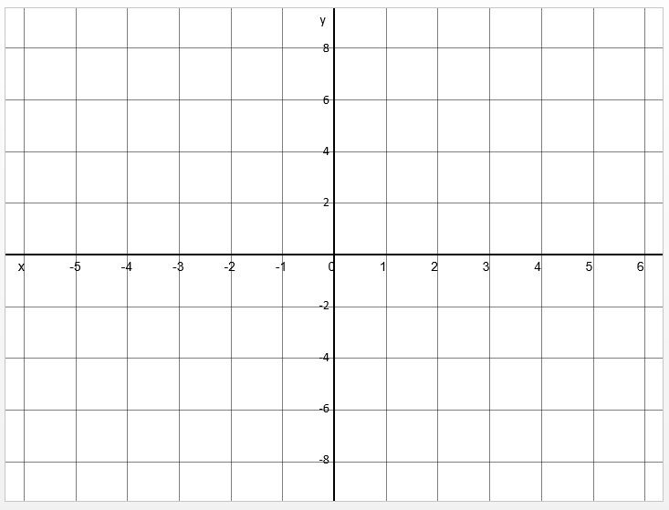

**Example 2:** Complete the table of values for $x+2y=1$.

|  |  |  |  |  |  |
| --- | --- | --- | --- | --- | --- |
| $$x$$ | $$-2$$ | $$-1$$ | $$0$$ | $$1$$ | $$2$$ |
| $$y$$ |  | $$1$$ |  |  |  |

**Question 1:** Draw the line with equation $x+y=2$

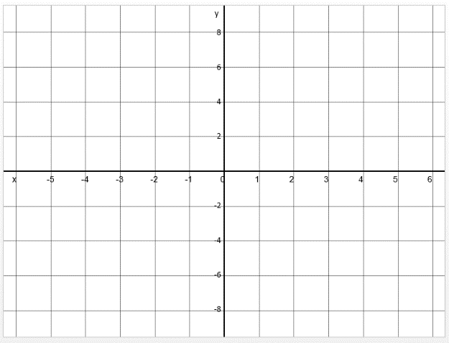

**Question 2:** Draw the line with equation $y=-\frac{1}{2}x+1$



**Question 3:** On the grid, draw the graph of *y* = 4*x* − 2



**Question 4.** (a) Complete the table of values for 3*x* + 2*y* = 6

|  |  |  |  |  |  |  |
| --- | --- | --- | --- | --- | --- | --- |
| *x* | –2 | –1 | 0 | 1 | 2 | 3 |
| *y* |  | 4.5 | 3 |  |  | –1.5 |

**(2)**

(b) On the grid, draw the graph of 3*x* + 2*y* = 6

**

**(2)**

**Question 5:** Put a tick or cross to determine whether each of the following points are on the line with the given equation.

|  |  |  |
| --- | --- | --- |
|  | $$y=1-x$$ | $$x+2y=3$$ |
| $$\left(3,-2\right)$$ |  |  |
| $$\left(1,2\right)$$ |  |  |
| $$\left(2,\frac{1}{2}\right)$$ |  |  |
| $$\left(-1,2\right)$$ |  |  |

**Question 6:** For the given equation of a line and point, indicate whether the point is above the line, on the line or below the line. (Hint: Find out first what $y$ is on the line for the given $x$)

|  |  |  |  |  |
| --- | --- | --- | --- | --- |
|  |  | Below the line | On the line | Above the line |
| $$y=3x+4$$ | $$\left(3,11\right)$$ |  |  |  |
| $$x+y=5$$ | $$\left(7,-2\right)$$ |  |  |  |
| $$y=3-2x$$ | $$\left(-3,10\right)$$ |  |  |  |
| $$2x+3y=4$$ | $$\left(\frac{3}{4},\frac{4}{5}\right)$$ |  |  |  |

Question 1: The equation of a line is $ax+by=c$. If the $x$ value of some point on the line is $d$, what is the full coordinate of the point, in terms of $a, b, c, d$?

Question 2: What is the area of the region enclosed between the line with equation $2x+7y=3$, the $x$ axis, and the $y$ axis?